**Project 7**

**Project Name:** Project-DevOps-Jenkins-Installation and Configuration on Linux

* Go to super user with command- sudo su and then install java using command – yum install java-1.8*

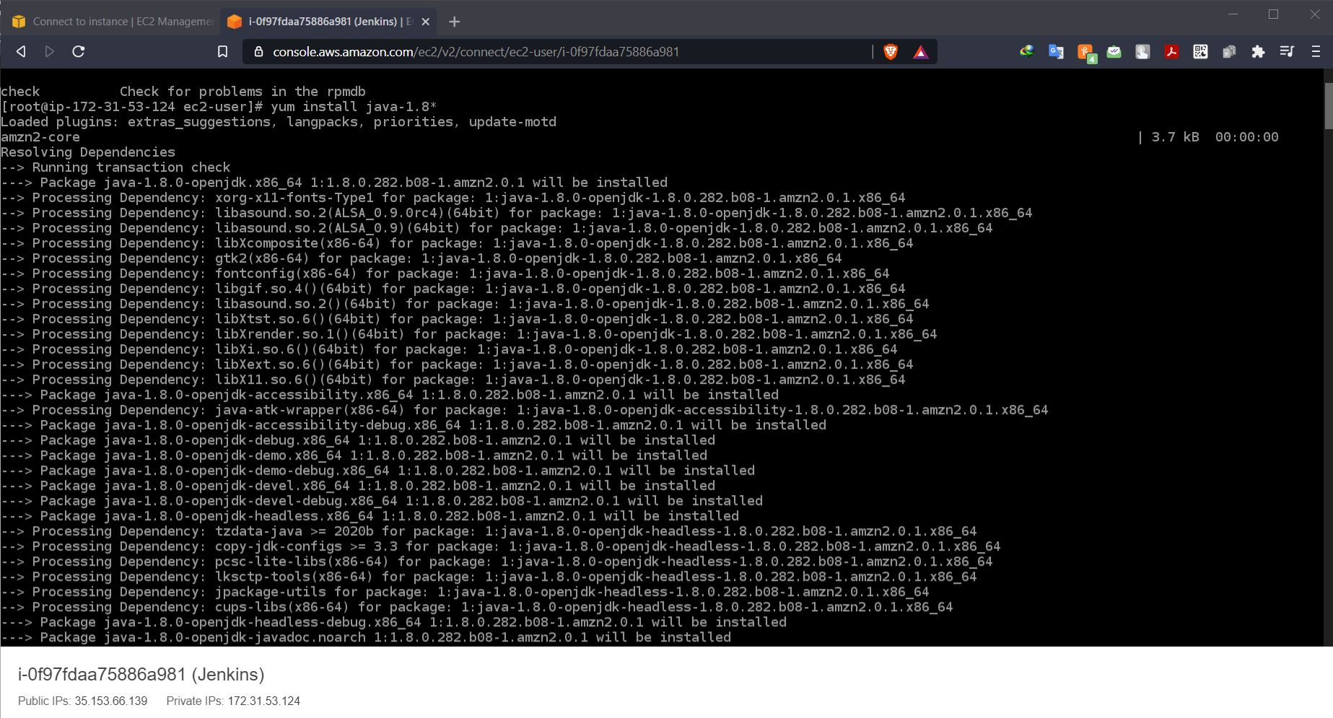

* Adding Jenkins repo with command - wget -O /etc/yum.repos.d/jenkins.repo https://pkg.jenkins.io/redhat-stable/jenkins.repo

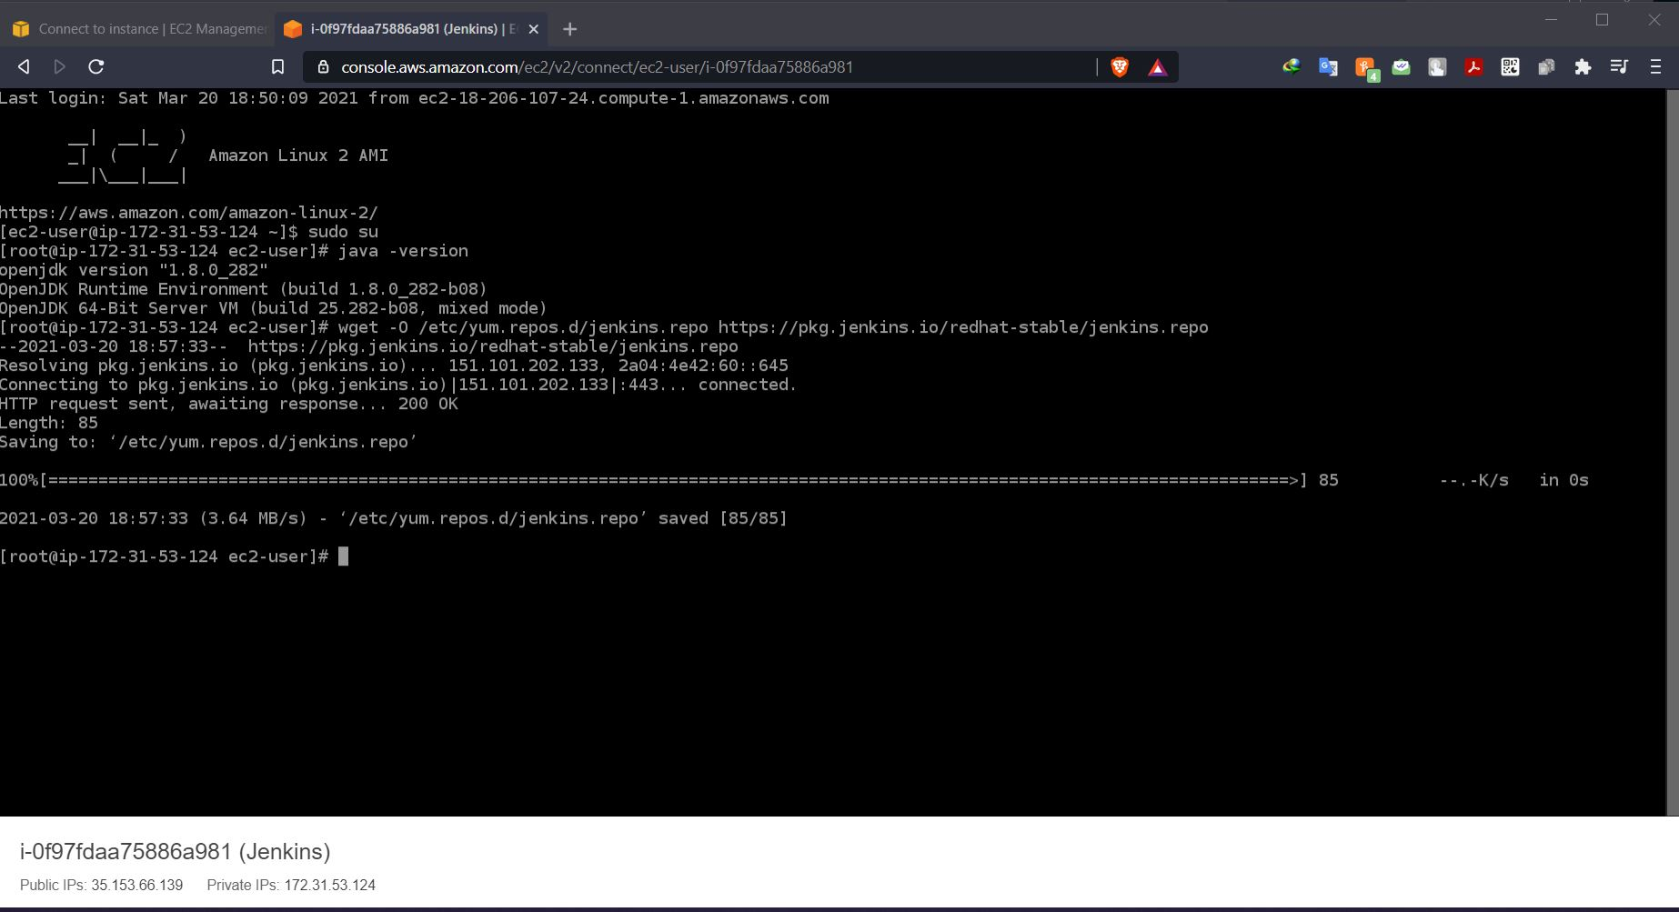

* Adding Jenkins key with command - rpm --import https://pkg.jenkins.io/redhat-stable/jenkins.io.key

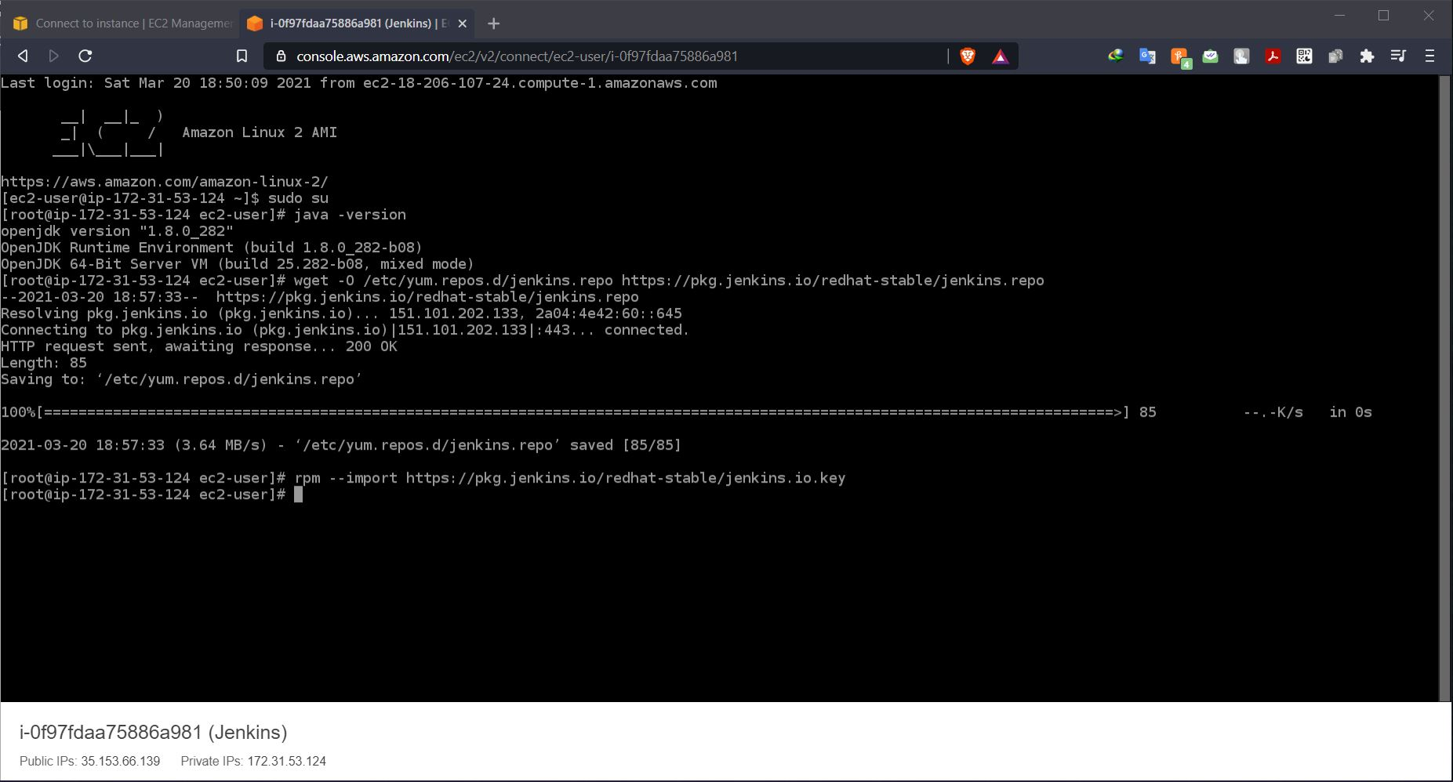

* Install Jenkins using command – yum install Jenkins

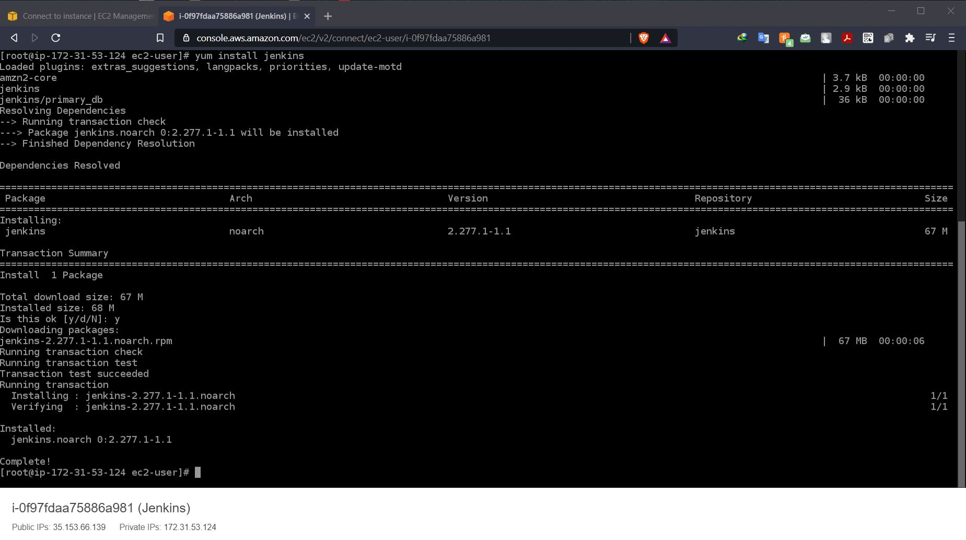

* Check status & Start Jenkins service using command – service Jenkins status and service Jenkins start

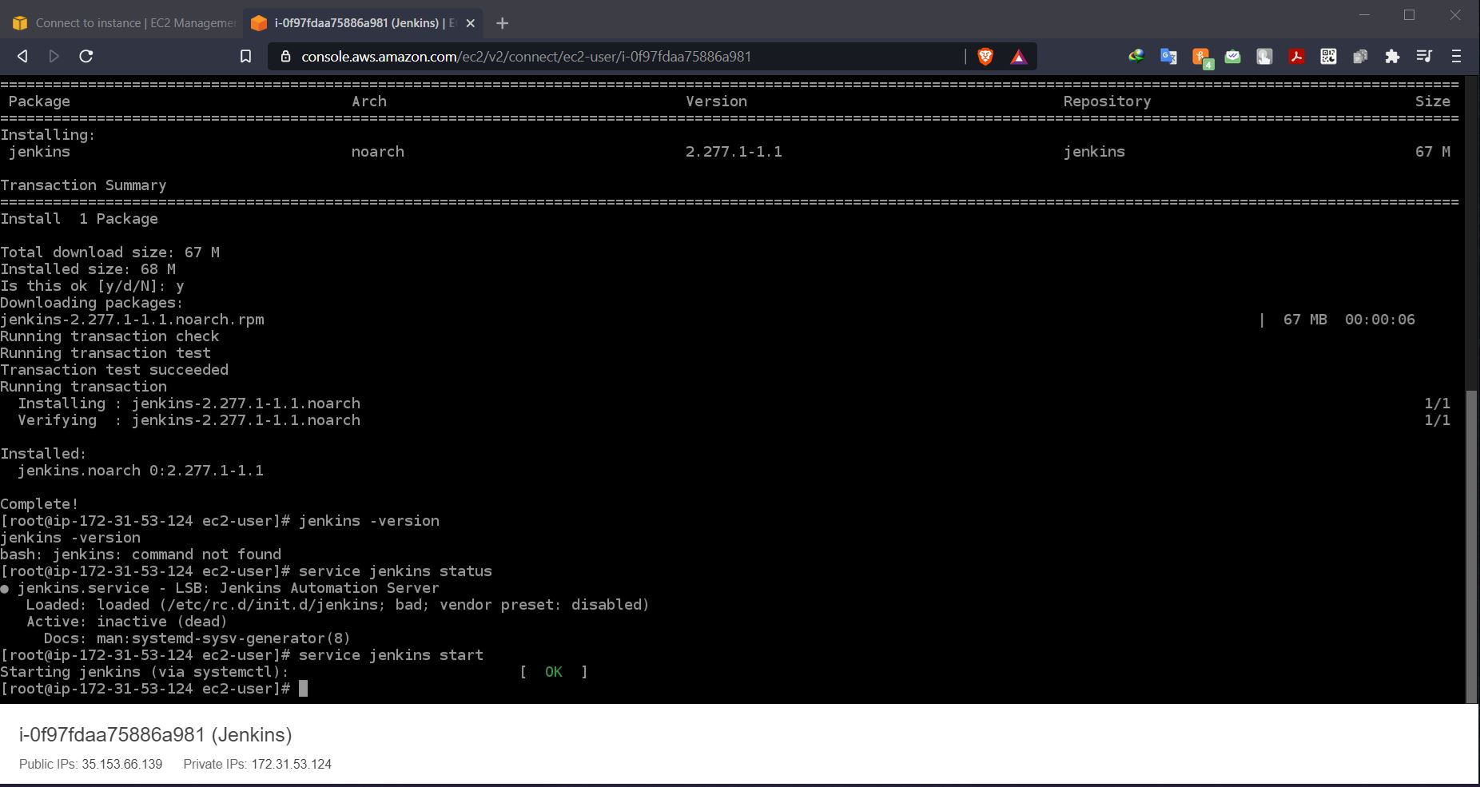

* Jenkins password location with Jenkins running on IP and port no - 100.24.244.48:8080

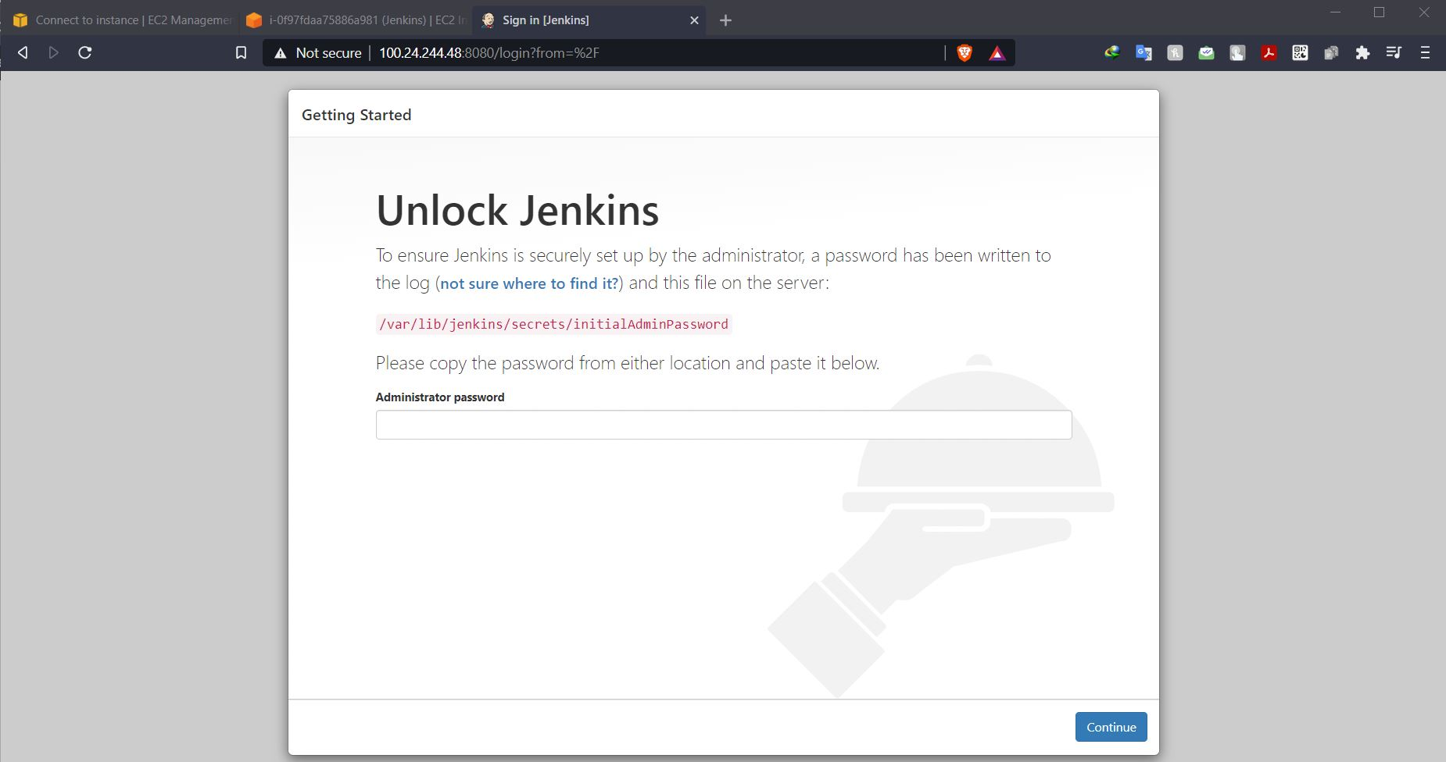

* Extracting Jenkins password using command - cat/var/lib/Jenkins/secrets/initialAdminpassword

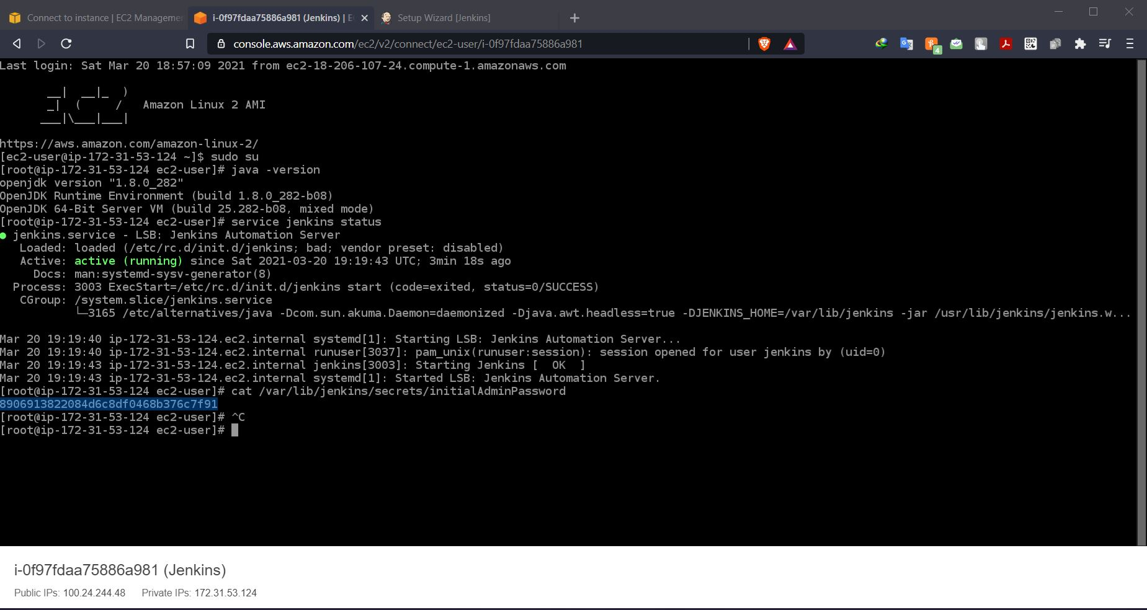

* Skip installing plugins and start using Jenkins

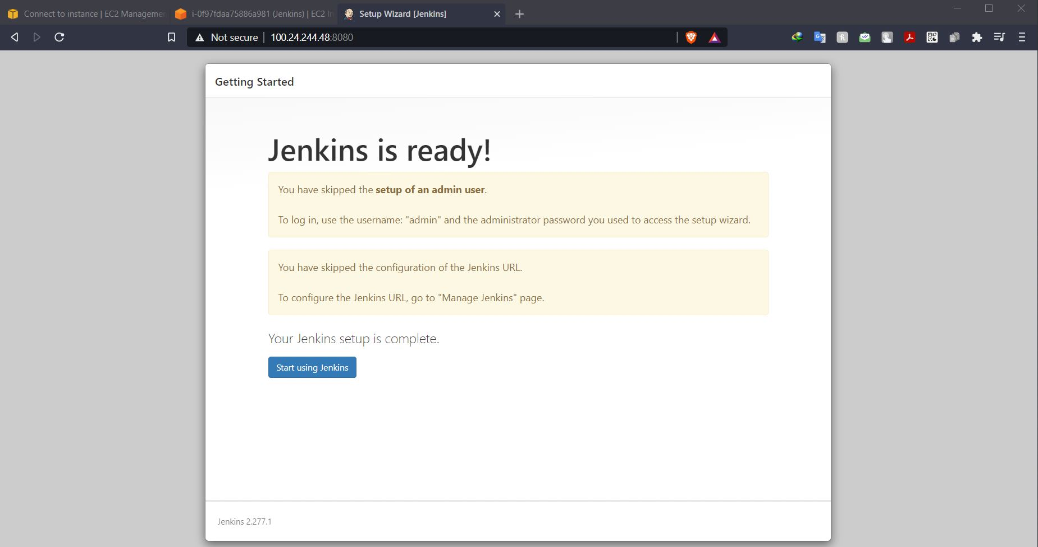

* Changing the admin with new password

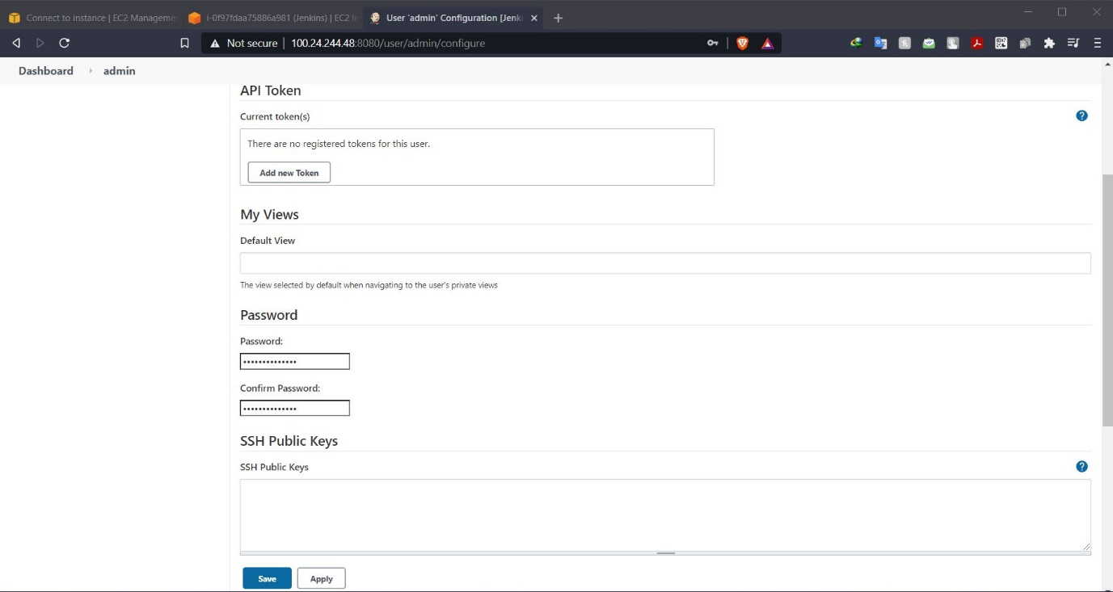

* Creating a new freestyle project with no source code

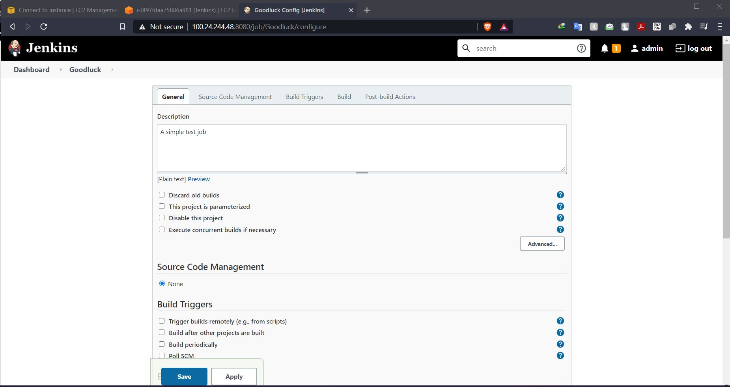

* Building an execute shell for displaying an echo message

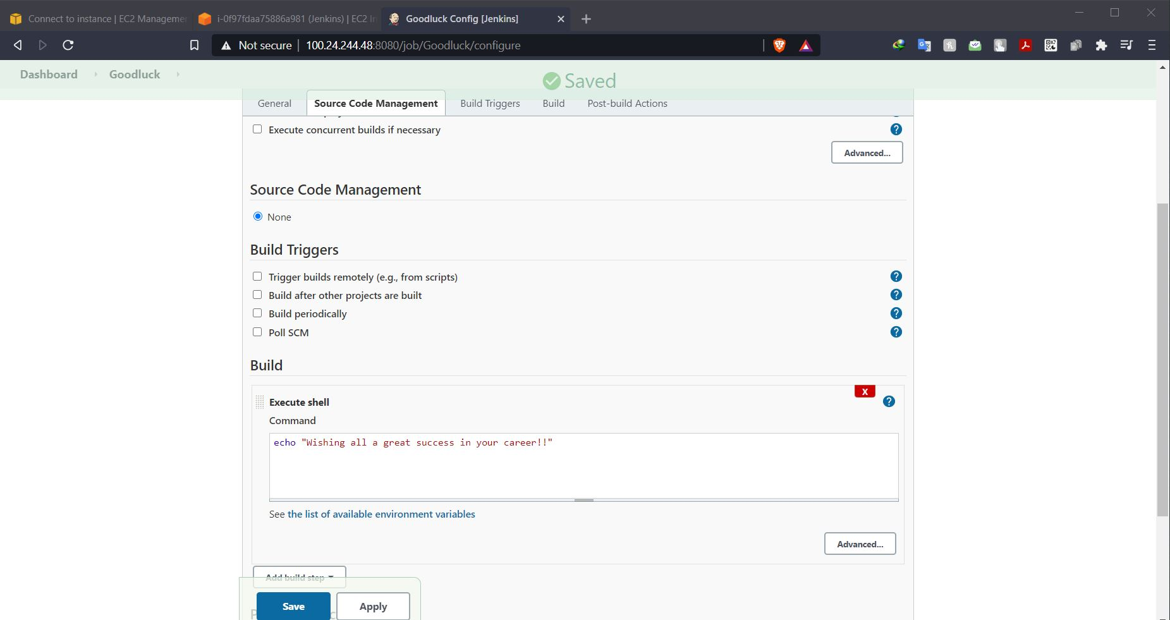

* Build the job with console output

